Freeze Dryer Capacity & Tray Allowance
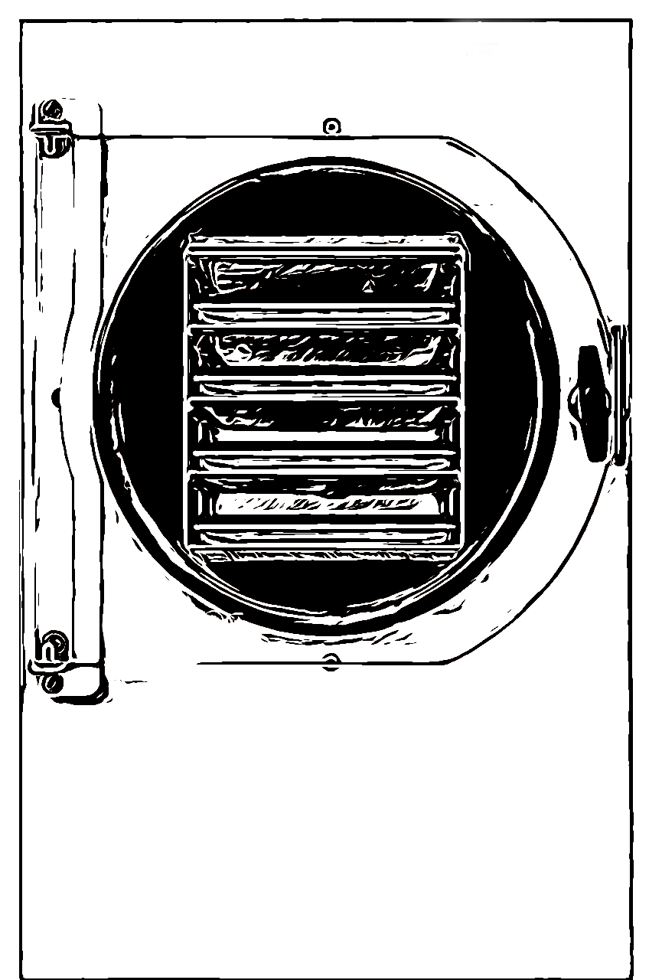
Small Freeze Dryer
each tray holds 5 Cups
*3 trays = 15 Cup total capacity

Medium Freeze Dryer
each tray holds 6 Cups
*4 trays = 24 Cup total capacity

Large Freeze Dryer
each tray holds 8 Cups
*5 trays = 40 Cup total capacity

*these are suggested capacities and totals for the recipes provided in this cookbook. This is not a representation of manufacturers recommendations.

